Selection: 1

| Please choose a lesson, or type 0 to return to course menu.

1: Introduction 2: Probability1 3: Probability2

4: ConditionalProbability 5: Expectations 6: Variance

7: CommonDistros 8: Asymptotics 9: T Confidence Intervals

10: Hypothesis Testing 11: P Values 12: Power

13: Multiple Testing 14: Resampling

Selection: 14

| Attempting to load lesson dependencies...

| Package ‘reshape2’ loaded correctly!

| Package ‘ggplot2’ loaded correctly!

| | | 0%

| Resampling. (Slides for this and other Data Science courses may be found at github

| https://github.com/DataScienceSpecialization/courses/. If you care to use them, they

| must be downloaded as a zip file and viewed locally. This lesson corresponds to

| 06_Statistical_Inference/13_Resampling.)

...

| |= | 1%

| In this lesson, you get a bonus! We'll talk about two topics in statistical inference,

| bootstrapping AND permutation testing. These both fall under the broader category of

| resampling methods. We'll start with bootstrapping.

...

| |== | 3%

| The bootstrap is a handy tool for making statistical inferences. It is used in

| constructing confidence intervals and calculating standard errors for statistics that

| might be difficult for some reason (e.g., lack of data or no closed form). Wikipedia

| tells us that bootstrapping is a technique which "allows estimation of the sampling

| distribution of almost any statistic using very simple methods." Simple is good,

| right?

...

| |=== | 4%

| The beauty of bootstrapping is that it avoids complicated mathematics and instead uses

| simulation and computation to infer distributional properties you might not otherwise

| be able to determine.

...

| |==== | 6%

| It's relatively new, developed in 1979, by Bradley Efron, a Stanford statistician. The

| basic bootstrap principle uses OBSERVED data to construct an ESTIMATED population

| distribution using random sampling with replacement. From this distribution

| (constructed from the observed data) we can estimate the distribution of the statistic

| we're interested in.

...

| |====== | 7%

| So, in bootstrapping the observed data substitutes for what?

1: a statistic

2: a population

3: a hypothesis

4: observations

Selection: 2

| You are doing so well!

| |======= | 8%

| So, in bootstrapping if the observed data is the population, what would the random

| samplings correspond to?

1: observations

2: a hypothesis

3: a population

4: a statistic

Selection: 1

| Your dedication is inspiring!

| |======== | 10%

| In effect, the original observed sample substitutes for the population. Our samplings

| become observations from which we estimate a statistic and get an idea about its

| distribution. This lets us better understand the underlying population (from which we

| didn't have enough data).

...

| |========= | 11%

| Here's a critical point. In constructing the estimated distribution we sample the

| observed data WITH replacement. If the original sample is n long and we sampled n times

| without replacement what would we get?

1: a better sample

2: the original sample permuted

3: a worse sample

4: an entirely new sample

Selection: 2

| That's the answer I was looking for.

| |========== | 12%

| The motivating example from the slides involves computing the average of 50 rolls of a

| die. Of course we can do this theoretically when we know that the die is fair.

| Remember, E(x) = Sum(x*p(x)) for x=1,2,...6, and p(x)=1/6 for all values of x.

...

| |=========== | 14%

| For the heck of it, compute the expected die roll for a fair die.

> sum(1:6)*1/6

[1] 3.5

| Perseverance, that's the answer.

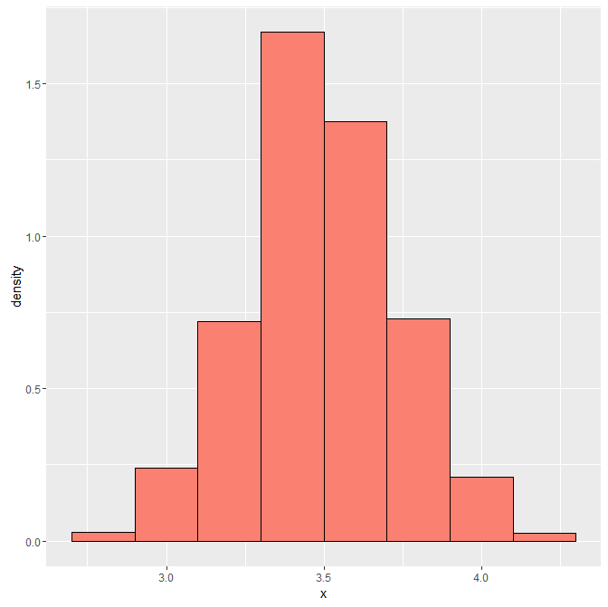

| |============ | 15%

| Theoretically, the average is 3.5. Here, we've run code and plotted a histogram after

| we took 1000 such averages, each of 50 dice rolls. Note the unusual y-axis scale. We're

| displaying this as a density function so the area of the salmon-colored region is

| theoretically 1. With this scale, though, all the heights of the bins actually add up

| to 5. So you have multiply each height by .2 and add up all the results to get 1.

...

| |============= | 17%

| The point is, the empirical matches the theoretical. Yay! The highest bin is centered

| at 3.5 just as the math predicted. So what?

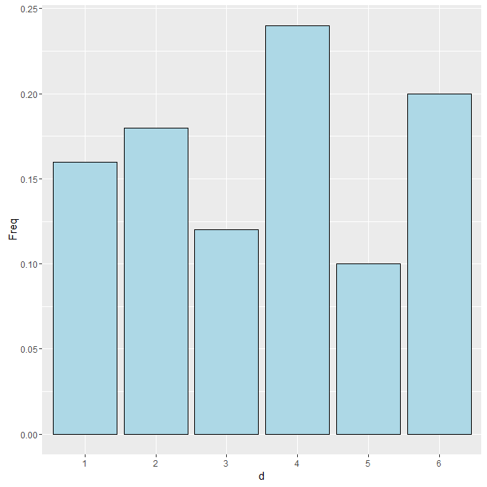

...

| |============== | 18%

| What if some joker wanted you to run the same experiment with a die he gave you and he

| warned you that the dice was loaded? In other words, it wasn't fair. It has some random

| distribution like this.

...

| |================ | 19%

| The outcomes aren't equally likely, are they? So when you do your 1000 runs of 50 rolls

| each, the density of the means looks different.

...

| |================= | 21%

| We've done this for you and put the result in g2. Type print(g2) now to see the

| picture.

> print(g2)

| You got it!

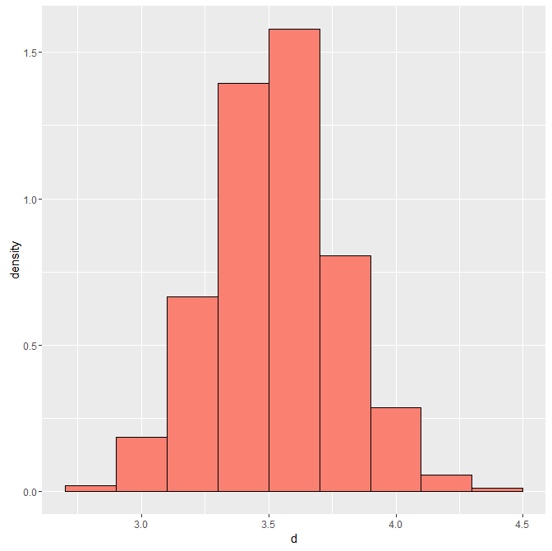

| |================== | 22%

| Picture's a little different, right? Although this example is a bit contrived, it

| illustrates an important concept. We really want a distribution of means and we have

| only one set of observations. (In this case it was the empirical distribution

| associated with the unfair die - the big blue picture.) We used that one distribution,

| to "create" many (1000) distributions by sampling with replacement from the given one.

| We sampled 50000 times so we created 1000 distributions of 50 rolls each.

...

| |=================== | 24%

| We then calculated the mean of each of our created distributions and got a distribution

| of means. Sampling the one distribution many times gives us some variability in the

| resulting statistics we calculate. We can then calculate the standard error and

| confidence intervals associated with the statistic.

...

| |==================== | 25%

| Before we go on to more theory, here's another example in which we'll try to find a

| distribution of medians of a population. Do you recall what a median is?

1: a person who talks to spirits

2: a point halfway between rare and well-done

3: 50th percentile

4: the most frequent outcome

Selection: 3

| That's correct!

| |===================== | 26%

| Recall the father and son height data. Once again, we've loaded it for you. We've

| placed the height of the sons in the vector sh and the length of this vector is stored

| in the variable nh. Use the R command head to look at the first few entries of sh.

> head(nh)

[1] 1078

| You almost had it, but not quite. Try again. Or, type info() for more options.

| Type head(sh) at the command prompt.

> head(sh)

[1] 59.77827 63.21404 63.34242 62.79238 64.28113 64.24221

| You are quite good my friend!

| |====================== | 28%

| Now look at nh to see how long sh is.

> nh

[1] 1078

| You're the best!

| |======================= | 29%

| Now we'll create 1000 distributions of the same length as the original sh. We'll do

| this by sampling sh with replacement 1000*nh times and store the results in an array

| with 1000 rows, each with nh entries. Then we'll take the median of each row and plot

| the result.

...

| |======================== | 31%

| Note that every time we draw from the empirical distribution sh, each of its nh data

| points is equally likely to be pulled, therefore the probability of drawing any one is

| 1/nh. The 1000 samples we create will vary from the original.

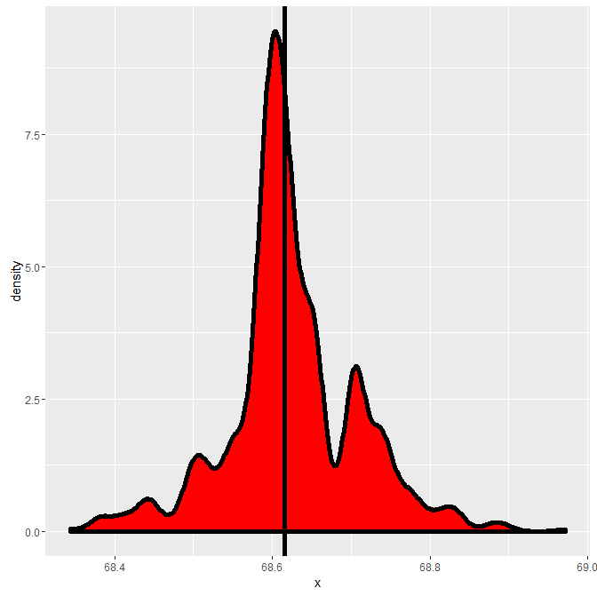

...

| |========================== | 32%

| Here's the resulting density curve. This estimates the distribution of medians. The

| thick vertical line shows where the median of the original, observed data sh lies.

...

| |=========================== | 33%

| We stored the 1000 medians of the resampled sets in the vector resampledMedians. Use

| the R function median to compute the median of numbers in this vector.

> median(resampledMedians)

[1] 68.61273

| That's a job well done!

| |============================ | 35%

| Now compute the median of the original sample sh.

> median(sh)

[1] 68.61582

| That's correct!

| |============================= | 36%

| Pretty close, right? Now back to theory. Suppose you have a statistic that estimates

| some population parameter, but you don't know its sampling distribution. The bootstrap

| principle uses the distribution defined by the observed data to approximate the

| sampling distribution of that statistic.

...

| |============================== | 38%

| The nice thing about bootstrapping is that you can always do it with simulation. The

| general procedure follows by first simulating B complete data sets from the observed

| data by sampling with replacement. Make sure B is large and that you're sampling WITH

| replacement to create data sets the same size as the original.

...

| |=============================== | 39%

| This approximates drawing from the sampling distribution of that statistic, at least as

| well as the data approximates the true population distribution. By calculating the

| statistic for each simulated data set and using these simulated statistics we can

| either define a confidence interval (e.g. find the 2.5 and the 97.5 percentiles) or

| take the standard deviation to estimate a standard error of that statistic.

...

| |================================ | 40%

| Notice that this process doesn't use any fancy math or asymptotics. The only assumption

| behind it is that the observed sample is representative of the underlying population.

...

| |================================= | 42%

| We've created the vector fh for you which contains the fathers' heights from the father

| son data we've been working with. It's the same length as the sons' data (1078) which

| is stored in nh. B, the number of bootstraps we want has been set to 1000. We'll do an

| example now in small steps.

...

| |================================== | 43%

| Our one sample of observed data is in the vector fh. Use the R function sample to

| sample fh nh*B times. Set the argument replace to TRUE. Put the result in the variable

| sam.

> sam <- sample(fh, nh*B, replace = TRUE)

| You got it!

| |==================================== | 44%

| Now form sam into a matrix with B rows and nh columns. Use the R function matrix and

| put the result in resam

> resam <- matrix(sam, B, nh)

| You're the best!

| |===================================== | 46%

| Now use the R function apply to take the median (third argument) of each row of resam

| (first argument). Put the result in meds. The second argument, the number 1, specifies

| that the application of the function is to the rows of the first argument.

> meds <- apply(resam, 1, median)

| You are doing so well!

| |====================================== | 47%

| Now look at the difference between the median of fh and the median of meds.

> median(fh) - median(meds)

[1] 0.004105

| You are quite good my friend!

| |======================================= | 49%

| Pretty close, right? Now use the R function sd to estimate the standard error of the

| vector meds.

> sd(meds)

[1] 0.1041889

| You are quite good my friend!

| |======================================== | 50%

| We previously did this same process for the sons' data and stored the resampled medians

| in the 1000-long vector resampledMedians. Find the standard error of resampledMedians.

> sd(resampledMedians)

[1] 0.08296743

| Keep working like that and you'll get there!

| |========================================= | 51%

| Now we'll find a 95% confidence interval for the sons' data with the R function

| quantile. The first argument is the vector of resampledMedians and the second is the

| expression c(.025,.975). Do this now.

> quantile(esampledMedians, c(.025,.975))

Error in quantile(esampledMedians, c(0.025, 0.975)) :

object 'esampledMedians' not found

> quantile(resampledMedians, c(.025,.975))

2.5% 97.5%

68.43733 68.80718

| All that practice is paying off!

| |========================================== | 53%

| Pretty close quantiles, right? Now do the same thing for the fathers' data. Recall that

| it's stored in the vector meds.

> quantile(meds, c(.025,.975))

2.5% 97.5%

67.54999 67.94110

| Keep up the great work!

| |=========================================== | 54%

| Another pair of close quantiles, but notice that these quantiles of the fathers'

| medians differ from those of the sons.

...

| |============================================ | 56%

| Bootstrapping is a very diverse and complicated topic and we just skimmed the surface

| here. The technique we showed you is nonparametric, that is, it's not based on any

| parameterized family of probability distributions. We used only one set of observations

| that we assumed to be representative of the population.

...

| |============================================== | 57%

| Finally, the confidence intervals we calculated might not perform very well because of

| biases but the R package bootstrap provides an easy fix for this problem.

...

| |=============================================== | 58%

| Now, to permutation testing, another handy tool used in group comparisons. As

| bootstrapping did, permutation testing samples a single dataset a zillion times and

| calculates a statistic based on these samplings.

...

| |================================================ | 60%

| Permutation testing, however, is based on the idea of exchangability of group labels.

| It measures whether or not outcomes are independent of group identity. Our zillion

| samples simply permute group labels associated with outcomes. We'll see an example of

| this.

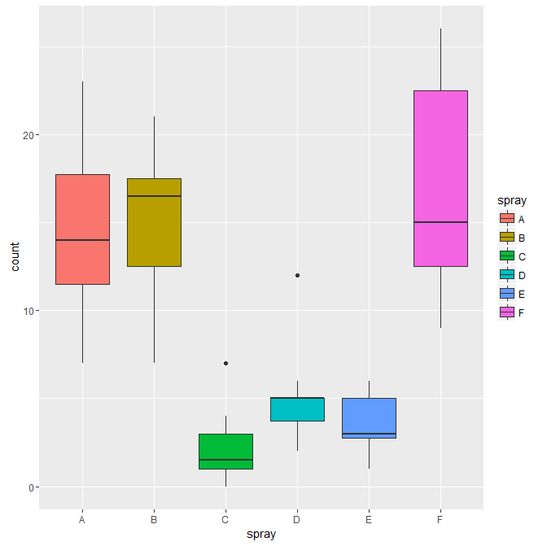

...

| |================================================= | 61%

| Here's a picture from the dataset InsectSprays which contains counts of the number of

| bugs killed by six different sprays.

...

| |================================================== | 62%

| We'll use permutation testing to compare Spray B with Spray C.

...

| |=================================================== | 64%

| Use the R command dim to find the dimensions of InsectSprays.

> dim(InsectSprays)

[1] 72 2

| Your dedication is inspiring!

| |==================================================== | 65%

| Now use the R command names to find what the two columns of InsectSprays contain.

> names(InsectSprays)

[1] "count" "spray"

| You are doing so well!

| |===================================================== | 67%

| We'll use permutation testing to compare Spray B with Spray C. We subsetted data for

| these two sprays into a data frame subdata. Moreover, the two data frames Bdata and

| Cdata contain the data for their respective sprays.

...

| |====================================================== | 68%

| Now use the R command range on Bdata$count to find the minimum and maximum counts for

| Spray B.

> range(Bdata$count)

[1] 7 21

| You nailed it! Good job!

| |======================================================== | 69%

| The picture makes more sense now, right? Now do the same for Spray C. Its data is in

| Cdata.

> range(Cdata$count)

[1] 0 7

| Your dedication is inspiring!

| |========================================================= | 71%

| From the ranges (as well as the picture), the sprays look a lot different. We'll test

| the (obviously false) null hypothesis that their means are the same.

...

| |========================================================== | 72%

| To make the analysis easier we've defined two arrays for you, one holding the counts

| for sprays B and C. It's call BCcounts. Look at it now.

> BCcounts

[1] 11 17 21 11 16 14 17 17 19 21 7 13 0 1 7 2 3 1 2 1 3 0 1 4

| Your dedication is inspiring!

| |=========================================================== | 74%

| The second array we've defined holds the spray identification and it's called group.

| These two arrays line up with each other, that is, the first 12 entries of counts are

| associated with spray B and the last 12 with spray C. Look at group now.

> group

[1] "B" "B" "B" "B" "B" "B" "B" "B" "B" "B" "B" "B" "C" "C" "C" "C" "C" "C" "C" "C" "C"

[22] "C" "C" "C"

| Keep up the great work!

| |============================================================ | 75%

| We've also defined for you a one-line function testStat which takes two parameters, an

| array of counts and an array of associated identifiers. It assumes all the counts come

| from group B or group C. It subtracts the mean of the counts from group C from the mean

| of the counts of group B. Type testStat with no parentheses and no arguments to see how

| it's defined.

> testStat

function(w, g) mean(w[g == "B"]) - mean(w[g == "C"])

<environment: 0x000000001a641050>

| You are amazing!

| |============================================================= | 76%

| Now set a variable obs by invoking testStat with the arguments BCcounts and group and

| assigning the result to obs.

> obs <- testStat(BCcounts , group)

| All that hard work is paying off!

| |============================================================== | 78%

| Take a peek at obs now.

> obs

[1] 13.25

| Nice work!

| |=============================================================== | 79%

| Pretty big difference, right? You can check this by using mean on Bdata$count and on

| Cdata$count and subtracting the latter from the former. Equivalently, you can just

| apply mean to Bdata$count-Cdata$count. Do either one now.

> mean(Cdata$count) - mean(Bdata$count)

[1] -13.25

| Keep trying! Or, type info() for more options.

| Type mean(Bdata$count)-mean(Cdata$count) at the command prompt.

> mean(Bdata$count)-mean(Cdata$count)

[1] 13.25

| Excellent work!

| |================================================================ | 81%

| So, mean(Bdata$count)-mean(Cdata$count) equals mean(Bdata$count-Cdata$count) because ?

1: mathemagic

2: the data is special

3: mean is linear

Selection: 3

| You got it right!

| |================================================================== | 82%

| Now this is where the permutation testing starts to involve resampling. We're going to

| test whether or not the particular group association of the counts affects the

| difference of the means.

...

| |=================================================================== | 83%

| We'll keep the same array of counts, just randomly relabel them, by permuting the group

| array. R makes this process very easy. Calling the function sample (which we've used

| several times in this lesson) with one argument, an array name, will simply permute the

| elements of that array.

...

| |==================================================================== | 85%

| Call sample now on the array group to see what happens.

> sample(group)

[1] "B" "B" "C" "B" "C" "C" "C" "C" "C" "C" "C" "B" "B" "B" "B" "C" "B" "B" "C" "B" "C"

[22] "B" "B" "C"

| Excellent job!

| |===================================================================== | 86%

| The labels are all mixed up now. We'll do this permuting of labels and then we'll

| recalculate the difference of the means of the two "new" (really newly labelled)

| groups.

...

| |====================================================================== | 88%

| We'll relabel and calculate the difference of means 10000 times and store the

| differences (of means) in the array perms. Here's what the code looks like perms <-

| sapply(1 : 10000, function(i) testStat(BCcounts, sample(group))). Try it now.

> perms <- sapply(1 : 10000, function(i) testStat(BCcounts, sample(group)))

| Perseverance, that's the answer.

| |======================================================================= | 89%

| We can take the mean of the virtual array of the boolean expression perms > obs. Do

| this now.

> mean(perms > obs)

[1] 0

| Nice work!

| |======================================================================== | 90%

| So on average 0 of the permutations had a difference greater than the observed. That

| means we would reject the null hypothesis that the means of the two sprays were equal.

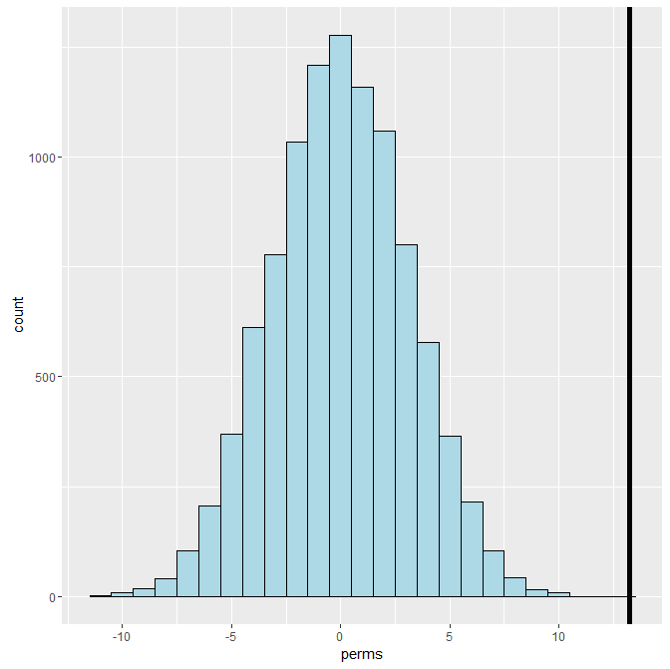

...

| |========================================================================= | 92%

| Here's a histogram of the difference of the means. Looks pretty normal, right? We can

| see that the distribution runs roughly between -10 and +10 and it's centered around 0.

| The vertical line shows where the observed difference of means was and we see that it's

| pretty far away from the distribution of the resampled permutations. This means that

| group identification did matter and sprays B and C were quite different.



...

| |========================================================================== | 93%

| Here's the picture of the InsectSprays again. Suppose we run the same experiment, this

| time comparing sprays D and E, which look more alike. We've redefined testStat to look

| at these sprays and subtract the mean of spray E from the mean of spray D.

...

| |============================================================================ | 94%

| We've also stored off the D and E data in DEcounts and the group labels in group. Run

| testStat now with DEcounts and group.

> testStat(DEcounts, group)

[1] 1.416667

| All that hard work is paying off!

| |============================================================================= | 96%

| We've stored off this value, 1.416667, in the variable obs for you. Now run the

| permutation command, with DEcounts. Here it is, perms <- sapply(1 : 10000, function(i)

| testStat(DEcounts, sample(group)))

> perms <- sapply(1 : 10000, function(i)testStat(DEcounts, sample(group)))

| That's correct!

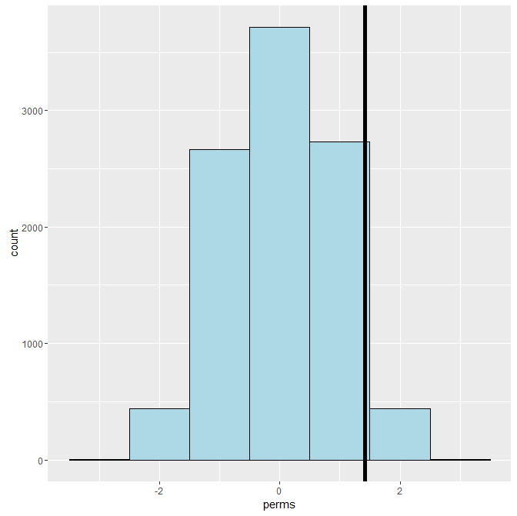

| |============================================================================== | 97%

| Finally, we can plot the histogram of the distribution of the difference of the means.

| We see that with these sprays the observed difference of means (the vertical line) is

| closer to the mean of the permuted labels. This indicates that sprays D and E are quite

| similar and we fail to reject the null hypothesis that the means were equal.

...

| |=============================================================================== | 99%

| Congrats! We hope you weren't bugged too much by this lesson and feel like you've

| pulled yourself up by your bootstraps.

...

| |================================================================================| 100%

| Would you like to receive credit for completing this course on Coursera.org?

1: No

2: Yes

Selection: 2

What is your email address? sweeyean@gmail.com

What is your assignment token? 3AzOkeD5JlNapq1t

Grade submission succeeded!

| Great job!

| You've reached the end of this lesson! Returning to the main menu...

| Please choose a course, or type 0 to exit swirl.

1: Statistical Inference

2: Take me to the swirl course repository!

Selection: